**Job Broad Platform**

**1. Users Table**

Stores data of users including job seekers and employers.

|  |  |  |
| --- | --- | --- |
| **Field Name** | **Data Type** | **Description** |
| user_id | INT (PK) | Unique Identifier for each user |
| full_name | VARCHAR | Full name of the user |
| email | VARCHAR | Email address used for login and contact |
| password | VARCHAR | Password for security |
| role | VARCHAR | User Type: Job Seeker or Employer |
| created_at | DATETIME | Date the account was created |

**2. Jobs Table**

Contains all job listings posted by employers.

|  |  |  |
| --- | --- | --- |
| **Field Name** | **Data Type** | **Description** |
| job_id | INT (PK) | Unique identifier for each job post |
| employer_id | INT(PK) | Linked to the employer posting the job |
| job_title | VARCHAR | Title of the job position |
| job_description | TEXT | Detailed job information |
| job_location | VARCHAR | City, region, or remote |
| salary_range | VARCHAR | Salary or pay range for the position |
| posted_at | DATETIME | Date when the job was posted |

**3. Employers Table**

Holds information about employer accounts and companies.

|  |  |  |
| --- | --- | --- |
| **Field Name** | **Data Type** | **Description** |
| employer_id | INT (PK) | Unique identifier for the employer |
| company_name | VARCHAR | Name of the company |
| industry | VARCHAR | Industry type |
| company_size | VARCHAR | Size of the company |
| contact_email | VARCHAR | Primary email for communication |
| is_verified | BOOLEAN | Indicates if the employer is verified |

**4. Applications Table**

Tracks all applications submitted by job seekers.

|  |  |  |
| --- | --- | --- |
| **Field Name** | **Data Type** | **Description** |
| application_id | INT (PK) | Unique identifier for the application |
| user_id | INT (FK) | Applicant’s user ID |
| job_id | INT (FK) | Job applied for |
| resume_link | VARCHAR | Link to the uploaded resume |
| cover_letter | TEXT | Optional message from applicant |
| application_status | VARCHAR | Pending, Accepted, Rejected |
| applied_at | DATETIME | Date the application was submitted |

**5. Saved Jobs Table**

Keeps track of job listings saved by job seekers.

|  |  |  |
| --- | --- | --- |
| **Field Name** | **Data Type** | **Description** |
| saved_job_id | INT (PK) | Unique ID for the saved job entry |
| user_id | INT (FK) | Users who saved the job |
| job_id | INT (FK) | Saved job’s ID |
| saved_at | DATETIME | Date the job was saved |

**Entity Relationship Diagram (ERD)**

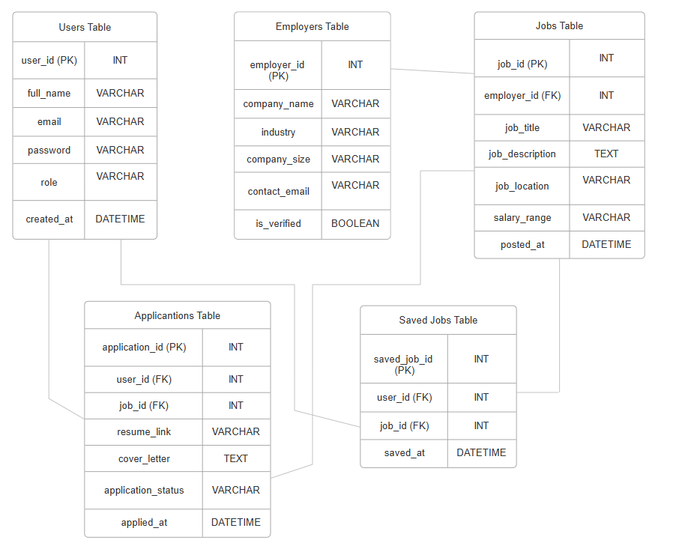

Figure 1. Job Broad Platform ERD

**System Flowchart (Flowchart)**

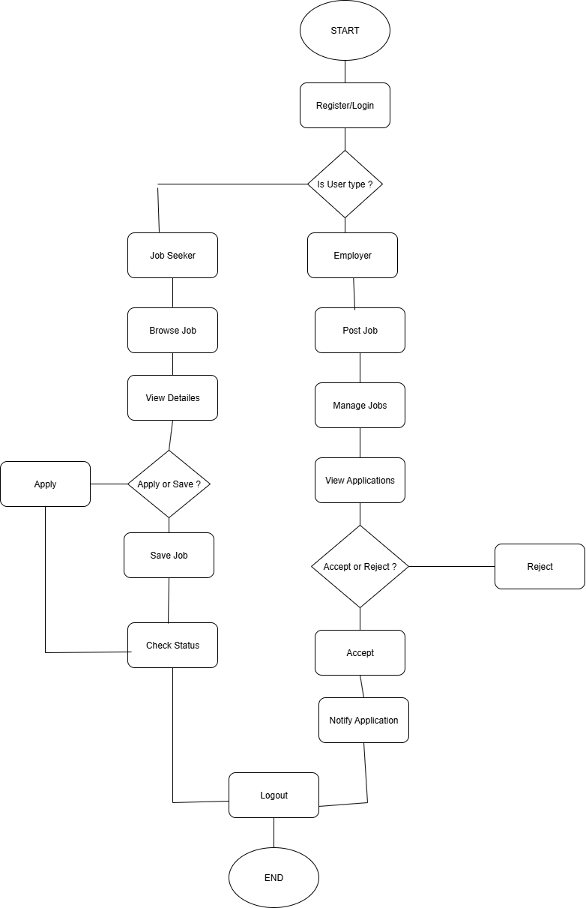

Figure 2. Job Broad Platform Flowchart